Basith Raja - JIRA Assignment – 15/11/2025

Table of Contents
Website Link: 2
Design Page: 2
Development Page: 2
GS - Design Module 2
Epic: 2
Stories: 2
Sub-Tasks: 3
GS - Development Module 4
Epic: 4
Stories: 4
Sub-Tasks: 5
Sprints 5
Sprint Creation and Added Items: 5
Active Sprints: 6
Completing the Sprint 6
Moved Item Through Workflow (Backlog → In Progress → Done) 7
From Backlog to Sprint 7
InProgress: 7
Done: 8
Bug Creation 8
Priority & Severity 10
Priority 10
Severity (Custom Added Field to the screen) 11

Website Link:

Design Page:
https://sites.google.com/view/growskill-it/growskill-it-design-page

Development Page:
https://sites.google.com/view/growskill-it/growskill-it-development-page?authuser=0

GS - Design Module

Epic:
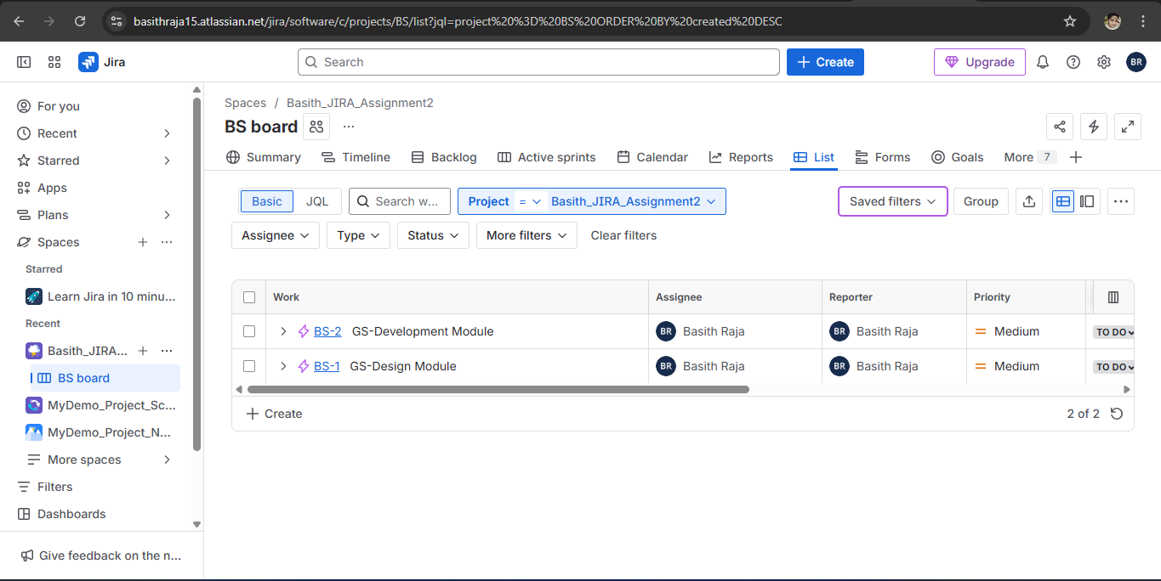

Stories:
- Create Wireframes for UI
- Collect Required Assets from Client
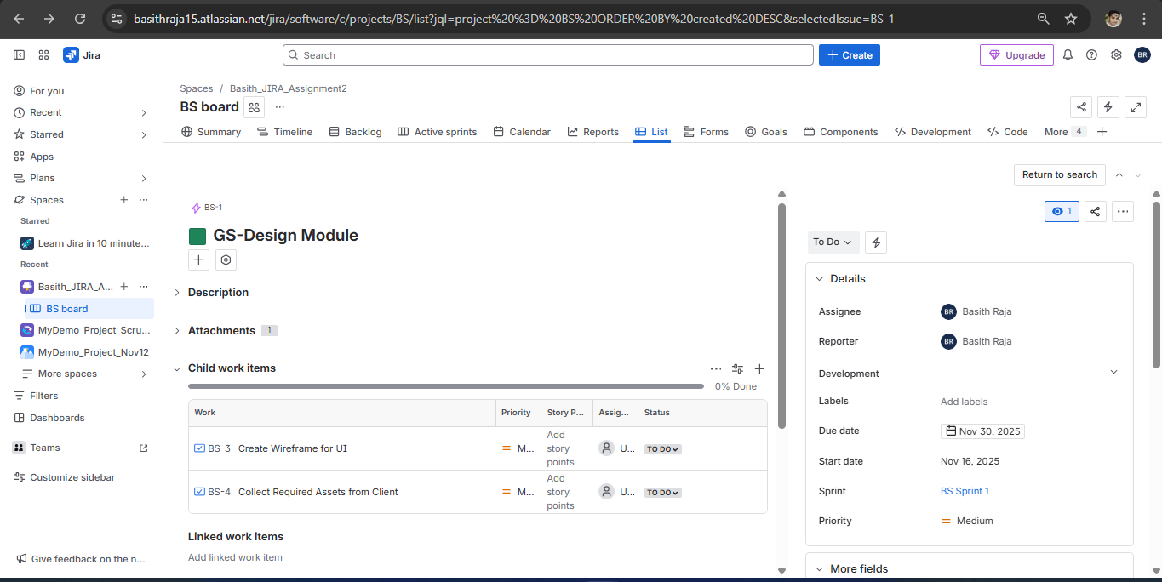

Sub-Tasks:
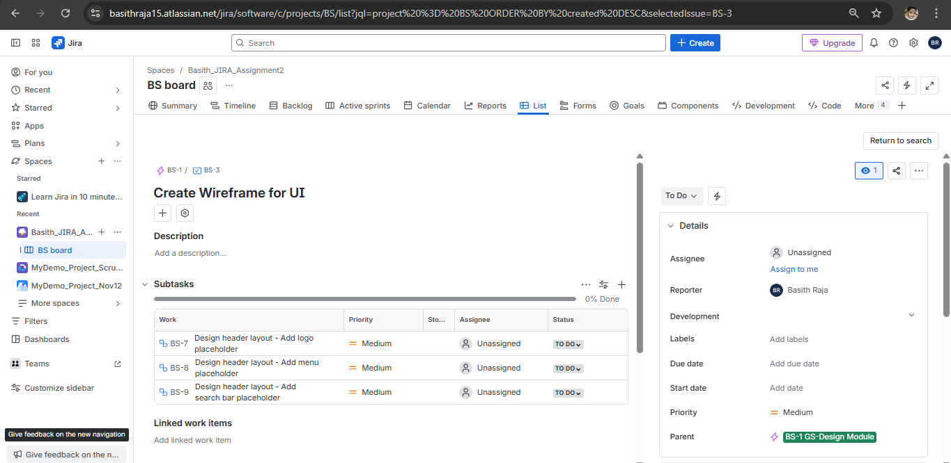

GS - Development Module

Epic:

Stories:
- Develop Home Page Layout
- Add Navigation Menu
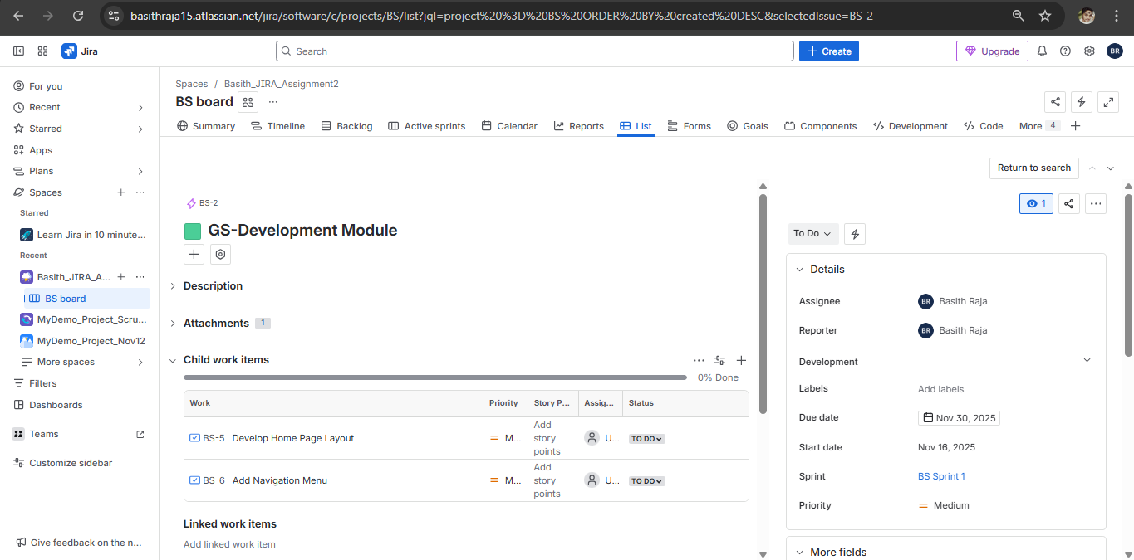

Sub-Tasks:
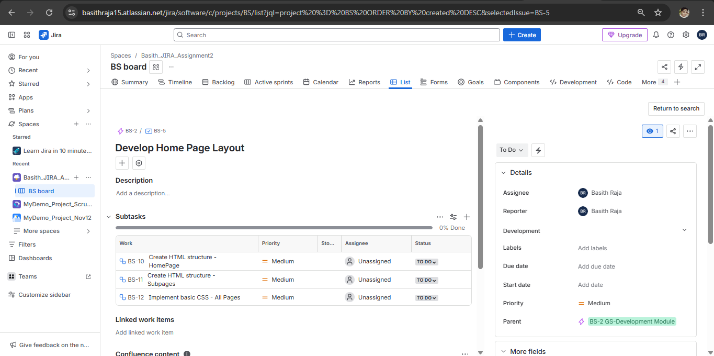

Sprints

Sprint Creation and Added Items:
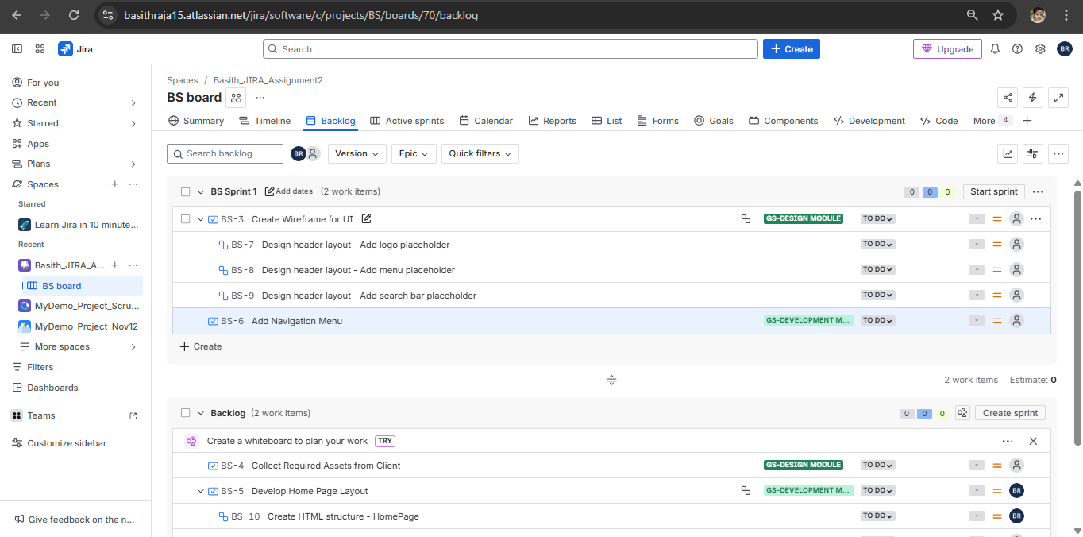

Active Sprints:
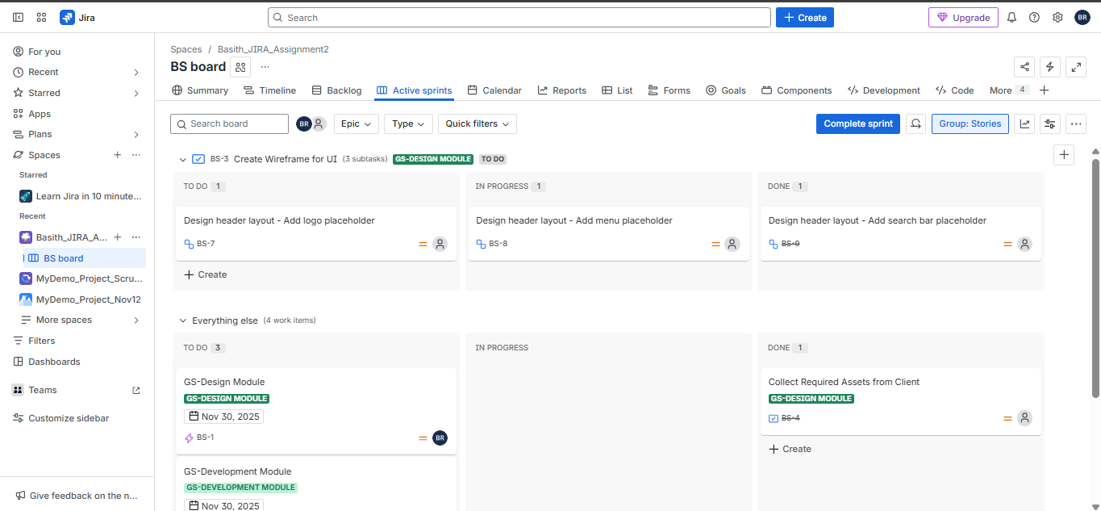

Completing the Sprint
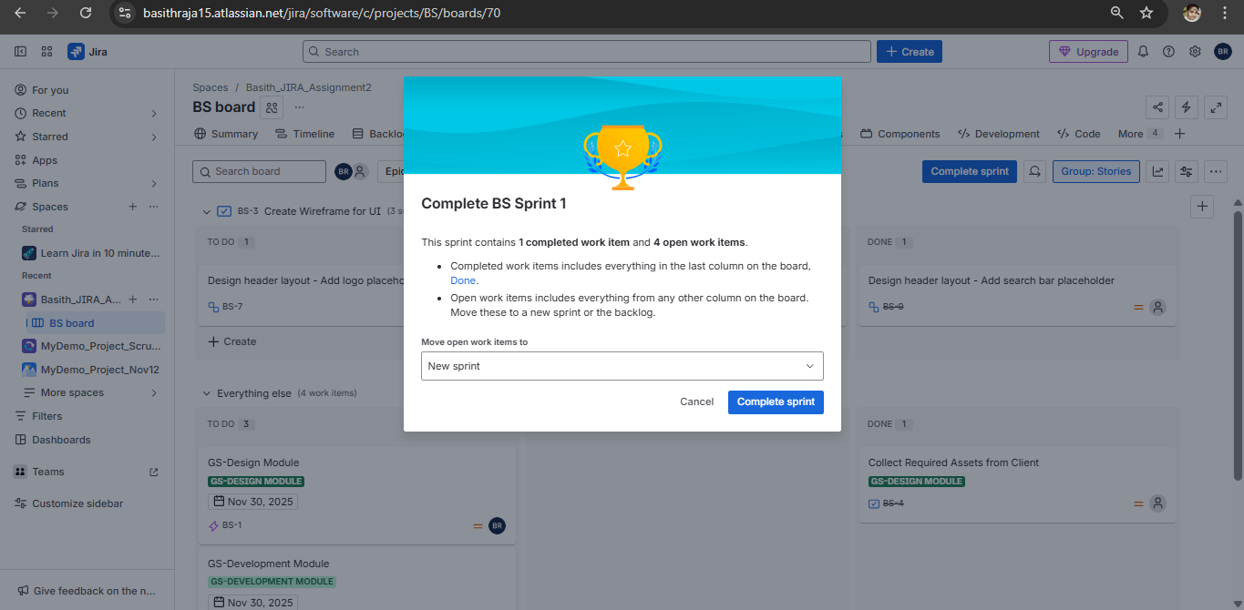

Moved Item Through Workflow (Backlog → In Progress → Done)

From Backlog to Sprint
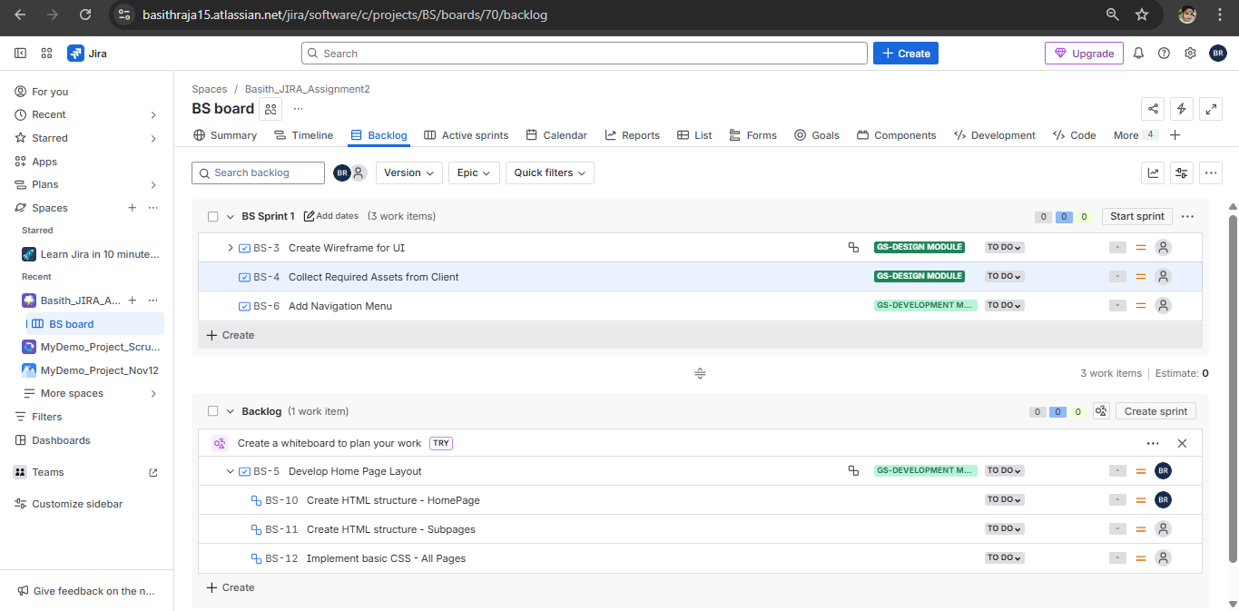

InProgress:
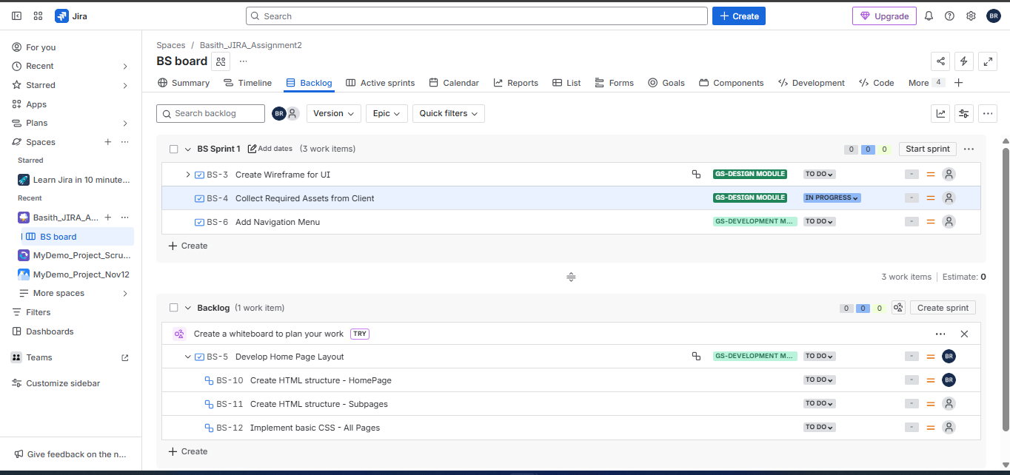

Done:
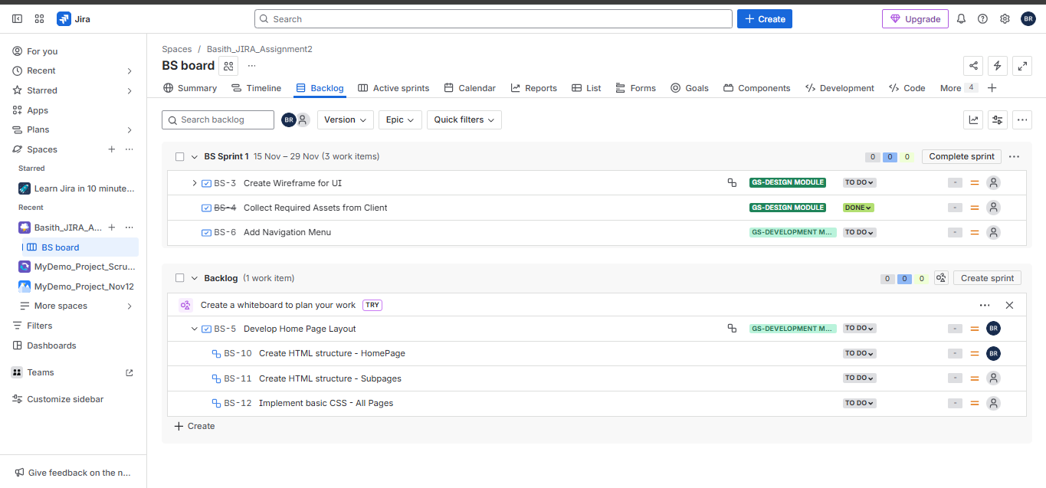

Bug Creation
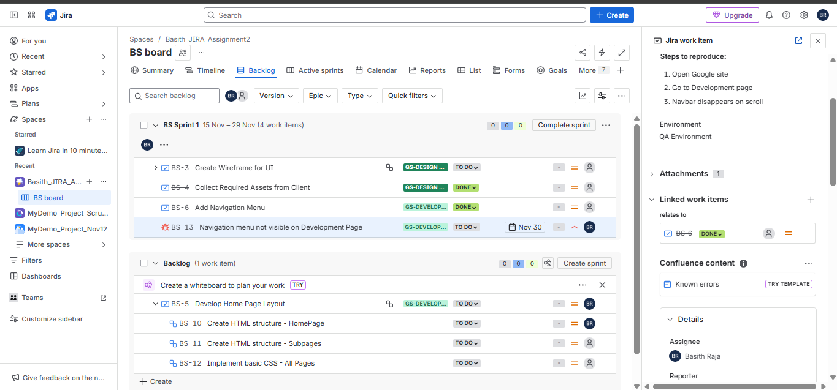

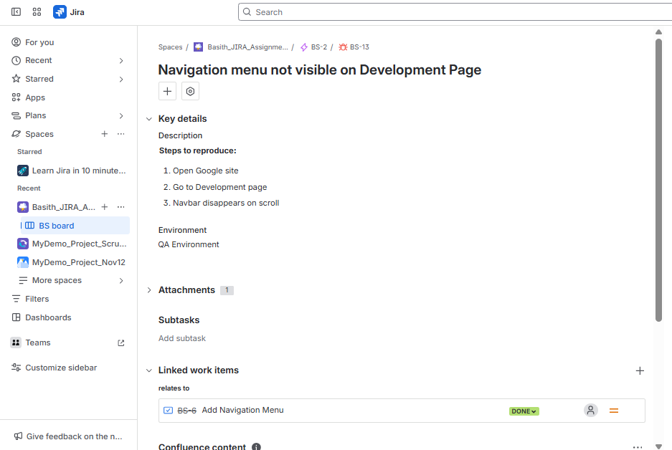

Priority & Severity

Priority
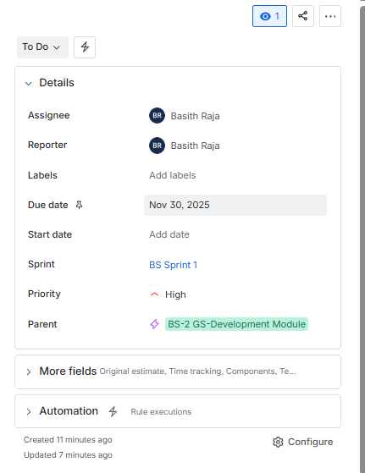

Severity (Custom Added Field to the screen)

